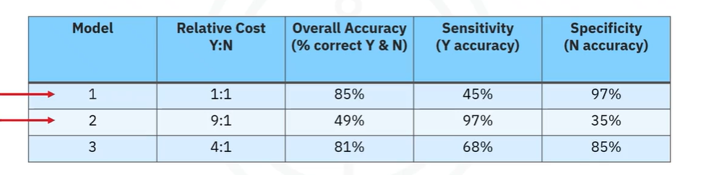

This table analyzes three different **Decision Tree Classification Models** for predicting **Congestive Heart Failure (CHF) readmission**. Each model uses a different **relative cost ratio** for misclassifying “Yes” (will be readmitted) and “No” (won’t be readmitted).

**Understanding the Columns**

1. **Relative Cost Y:N**
   * This adjusts how much more important it is to correctly classify “Yes” cases compared to “No” cases.
   * **Higher Y:N ratios** prioritize detecting readmissions (Yes).
   * **Lower Y:N ratios** keep a balance between detecting both Yes and No cases.
2. **Overall Accuracy (% correct Y & N)**
   * The percentage of all correctly classified cases (both Yes & No).
   * **Higher isn’t always better**—we must also check Sensitivity and Specificity!
3. **Sensitivity (Y Accuracy - Readmitted Cases) Recall**
   * How well the model detects **actual readmissions (Yes cases).**
   * **Higher sensitivity** means the model correctly identifies more high-risk patients.
4. **Specificity (N Accuracy - Non-Readmitted Cases)** 
   * How well the model detects **non-readmitted patients (No cases).**
   * **Higher specificity** means fewer false positives (wrongly predicting a patient will be readmitted).

**Breaking Down Each Model**

| **Model** | **Relative Cost (Y:N)** | **Overall Accuracy** | **Sensitivity (Y Accuracy)** | **Specificity (N Accuracy)** |
| --- | --- | --- | --- | --- |
| **1** | **1:1** (Equal weight) | **85%** | **45%** | **97%** |
| **2** | **9:1** (Strong bias for “Yes”) | **49%** | **97%** | **35%** |
| **3** | **4:1** (Moderate bias for “Yes”) | **81%** | **68%** | **85%** |

**Interpreting the Models**

**Model 1 (Baseline Model) → 1:1 Cost Ratio**

✅ **Good Overall Accuracy (85%)**  
❌ **Poor Sensitivity (Only 45% of readmissions detected)**  
✅ **High Specificity (97%) → Few false positives**

* **Problem?** It **misses** many actual readmissions (false negatives).

**Model 2 (Overcompensating for “Yes”) → 9:1 Cost Ratio**

❌ **Low Overall Accuracy (49%)**  
✅ **High Sensitivity (97%) → Detects almost all readmissions**  
❌ **Very Low Specificity (35%) → Too many false positives**

* **Problem?** Too many **false positives**, meaning **many patients are wrongly flagged as high-risk.**
* **This leads to unnecessary interventions.**

**Model 3 (Balanced Approach) → 4:1 Cost Ratio**

✅ **Good Overall Accuracy (81%)**  
✅ **Higher Sensitivity (68%) → Detects more readmissions**  
✅ **High Specificity (85%) → Fewer false positives than Model 2**

* **Best balance between detecting readmissions and avoiding unnecessary interventions.**

**Conclusion: Best Model?**

👉 **Model 3 (4:1 Cost Ratio) is the best balance!**

* It improves **Sensitivity** (detecting real readmissions) without sacrificing too much **Specificity** (wrongly predicting healthy patients as readmissions).
* **Model 1 was too weak at predicting readmissions.**
* **Model 2 overcompensated, causing too many false alarms.**